**BIRLA INSTITUTE OF SCIENCE AND TECHNOLOGY PILANI, HYDERABAD CAMPUS**

DIGITAL DESIGN LABORATORY (Session 2021-22)

Workbook Experiment -10

Full Name of the Student: Shyam N V

Complete ID of the student: 2020A7PS2081H

Title of the Experiment: Sequential Circuit Design using D Flip-Flops and Xilinx

D-Flip Flop with Reset

Problem 1:Design a Two-bit binary counter using D Flip-Flops (Provide proper snapshots and show the graphical output)

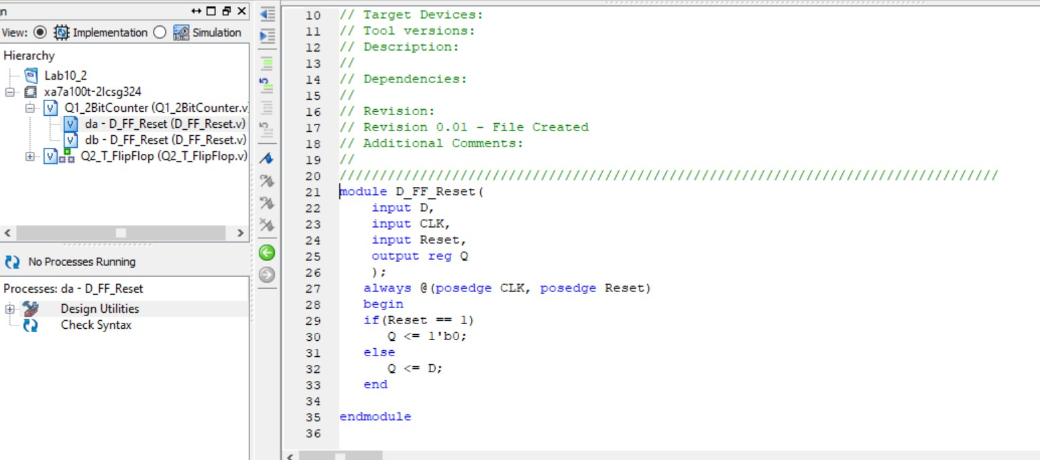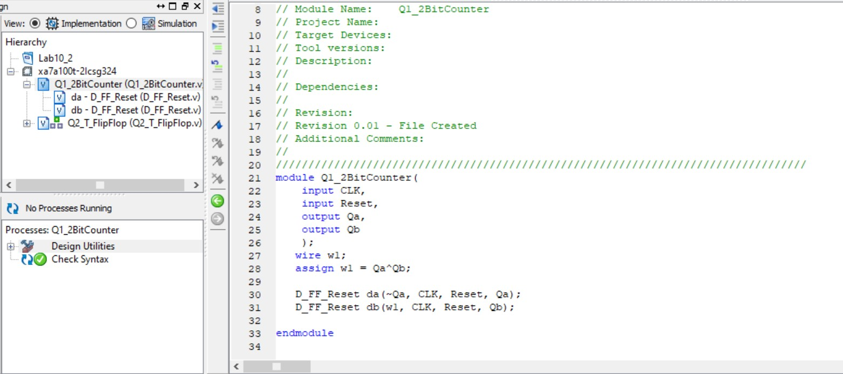

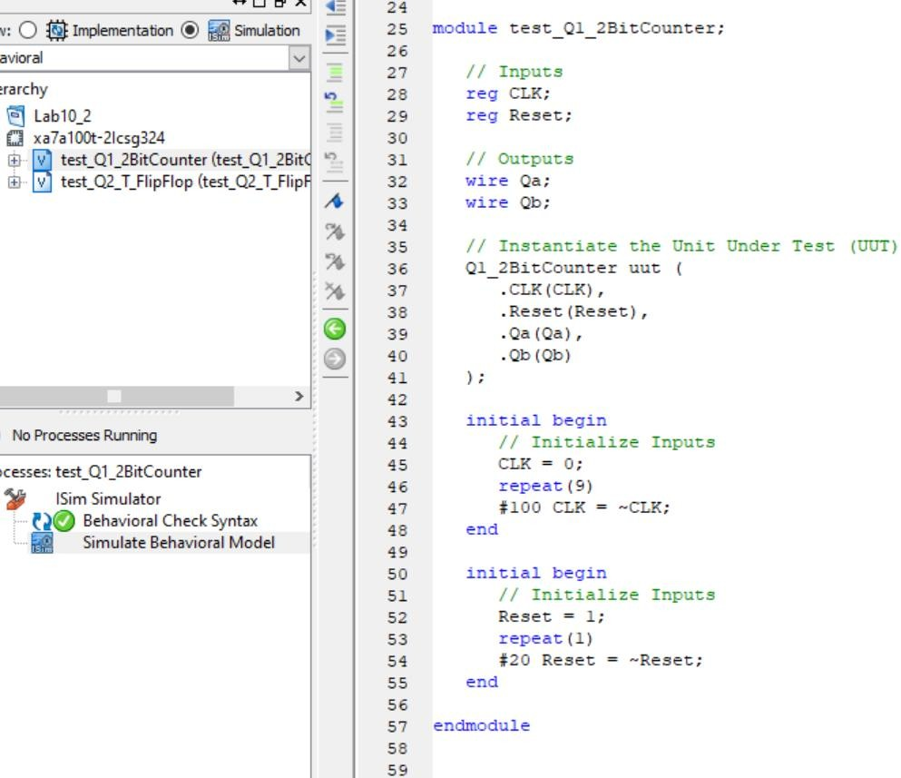

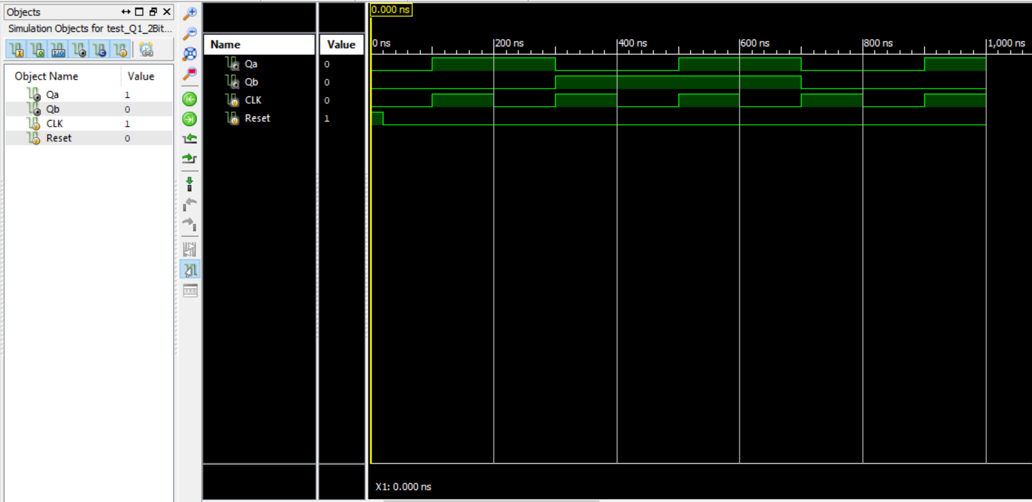

Problem 2:

Design a T Flip-flop circuit using D Flip-flop and an Ex-OR gate. (Provide proper snapshots and show the graphical output)

